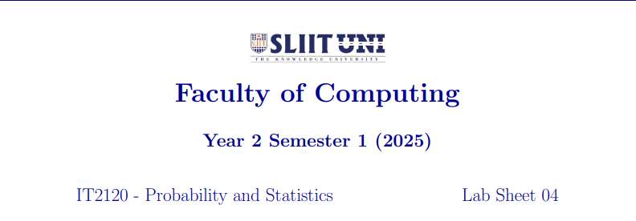

IT24102464

Pabasara P.V.I.

Exercise

1.



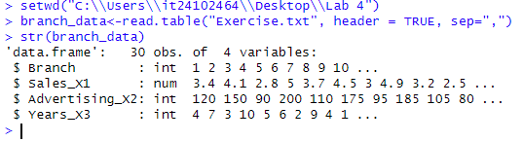

2. branch-Categorical(nominal)

Sales_X1-Quantitative (Ratio scale, continuous)

Advertising_X2-Quantitative (Ratio scale, continuous)

Years_X3-Quantitative (Ratio scale, discrete – whole years)

3.





4.



5.

